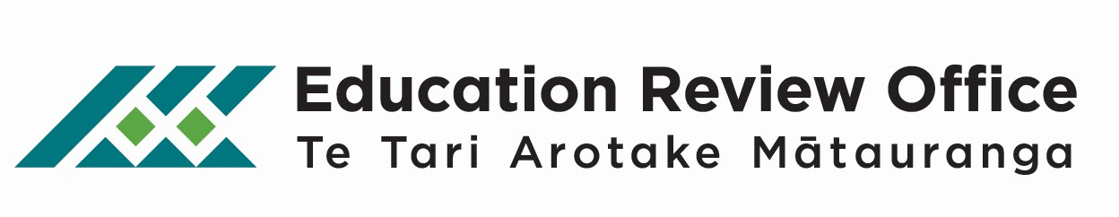

To the parents, whānau, aiga and staff

ERO’s Education Review of Your Early Childhood Service
The Education Review Office (ERO) will soon be reviewing your early childhood service. The manager of your service will let you know when the review team will be onsite.

What does ERO want to know?
We want to know how well placed your service is to contribute to learning and promote the wellbeing of all children, including Māori, Pacific and those with diverse needs.

To find this out, ERO will explore how well governance, management, leadership, partnership with parents and whānau, curriculum design and teaching practices are contributing to children’s learning and wellbeing. ERO will talk to adults and children, look at documents and observe aspects of the programme.

ERO will be interested in reviewing any information your service has about what is going well and also areas for development. We are very interested in how the service consults parents and whānau, and how they support you to participate in your child’s learning. Your service will also have to show that it meets its legal requirements and provides for the health and safety of your children.

ERO will also be interested in how staff are supported to contribute to improvements in the service for the benefit of children.

Once the review is over and we have all the information we need, we will summarise what we found in a brief report. The report will be sent to your service and will be published on our website after the review (www.ero.govt.nz).

As part of the review, ERO also evaluates specific topics that are national education priorities (such as literacy in early childhood services). These findings are combined with information from other early childhood services and then published as a national education evaluation report. You can see these reports on ERO’s website: www.ero.govt.nz/National-Reports.

How can you get involved?
Our review officers are happy to talk to parents, whānau and staff during the review. In some instances, the service or review team may arrange a meeting for you to attend.

You also have the opportunity to share your views on our website. To have your say, go to www.ero.govt.nz >> Review Process >> For Early Childhood Services and Nga Kohanga Reo >> Questionnaire about your ERO review.

We look forward to being in your early childhood service.

