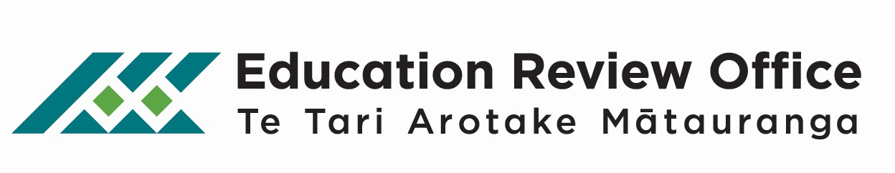
November 2013

ERO Early Childhood Service Questionnaire

ERO invites feedback from all Early Childhood Services following the confirmation of their ERO report. The questionnaire should take about 10 minutes to complete. Individual early childhood services will not be identified in any reporting.

Please post or fax the completed questionnaire to ERO or you can answer it online at:

http://www.surveymonkey.com/s/J5HHDJK

Section 1: Background information

- Early Childhood Service Name:
- Ministry of Education Profile Number:

- Please select the ERO return time indicated in your report:
- Previous review type:
- ERO region (refer to letter confirming report)
Report signed by (please tick the appropriate box):

Who has completed this questionnaire?
Role/Position (Tick if Involved)

Section 2: Review process

- To what extent were you able to contribute your views in the ERO review?
 | To a great extent | To some extent | To a limited extent | Not at all
Information in your Self Report was used by ERO
Your service’s self-review information contributed to ERO’s review
The review focused on what was relevant for your early childhood service
You were given opportunities to talk to ERO about your service’s strengths and next steps

- How well did the review acknowledge and build on your service’s strengths?
 | Very well | Quite well | Not well
Service’s strengths

- How well did the review identify or confirm relevant next steps for your service?
 | Very well | Quite well | Not well
Service’s next steps

- How well did the review make use of your service’s self review?
 | Very well | Quite well | Not well
Complementing self review

- How well did the review contribute to your understanding of self review?
 | Very well | Quite well | Not well
Understanding

- How well did ERO complement and support your focus on priority learners?
 | Very well | Quite well | Not well | N/A
Māori children
Pacific children
Children with diverse learning needs
Children up-to-two years of age
Other (please specify)
- Do you have any further comments about Q12?

- How useful did you find the document ‘He Pou Tātaki - How ERO reviews early childhood services’ during the review?
 | Very useful | Quite useful | Not useful
ERO’s document

- How useful do you think ‘He Pou Tātaki - How ERO reviews early childhood services’ will be to you after the review?
 | Very useful | Quite useful | Not useful
Future use

- Overall, how useful was your ERO review?
 | Very useful | Quite useful | Not useful
Review process

- Please add any comments about any aspect of the review:

Section 3: Written report

- To what extent do you agree with the following statements about the report:
 | Strongly agree | Agree | Disagree | Strongly disagree
The report identifies what is important to our early childhood service
Findings in the report reflect discussions with ERO at our service
The report is useful to parents and the community
The report complements and supports our early childhood service’s self review
- Overall, how useful was the written report?
 | Very useful | Quite useful | Not useful
Written report

- If you have any specific comments about the written report please comment here:

- If you have any suggestions about how ERO could improve its review process, please comment here:

22. Further contact with ERO

You have completed the survey.

Thank you for taking the time to complete this questionnaire.
Your feedback will help ERO to refine and revise its reviews of early childhood services.
Individual early childhood services will not be identified in any reporting. Please email us at info@ero.govt.nz if you have any queries.

Please email a completed Word version to: info@ero.govt.nz or fill out a hard copy and post or fax to:
Assistant Analyst – Evaluation Services

Education Review Office

National Office – Te Tari Matua
PO Box 2799
Wellington 6140

Fax: 04 499 2482

